# Practice 10

Pasteurization plant

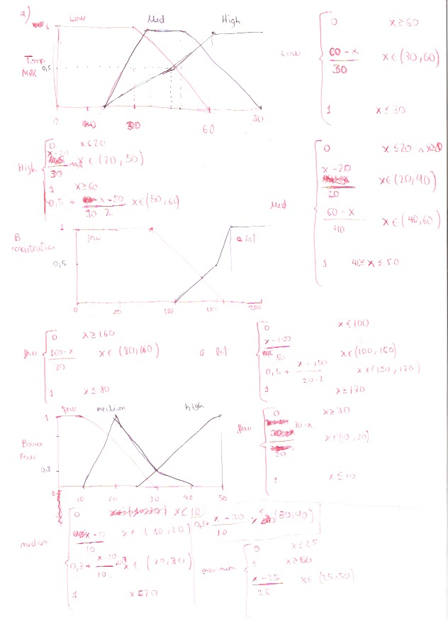

In this one, when temperature is moderate, it last an ecuation in interval x - (30,40):

0.3* (40 – x) / 10

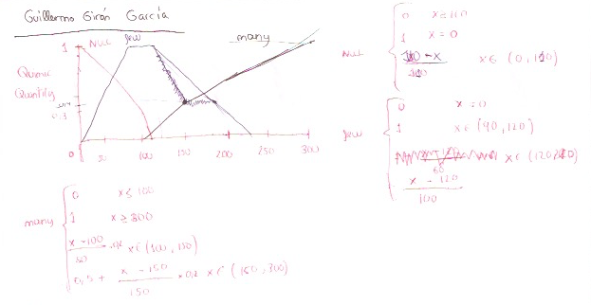

When few chemicals are needed, it last an equation, when x is in the interval (0, 90):

90 – x / 90

b)

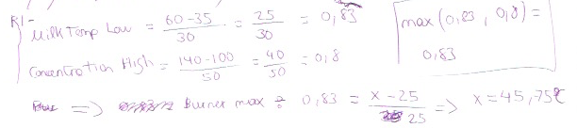

In r3, consequent for burner is:

0,75 = 0,3 + ((x-20)/10) * 0,7 -> x = 26,4

